Amazon Web Services

**Subnet**

## A subnet is a segment of an Amazon VPC’s IP address range where you can launch Amazon **EC2 instances**, Amazon **Relational Database** **Service (Amazon RDS) databases**, and other AWS resources.

## We can add one or more subnets in each Availability Zone.

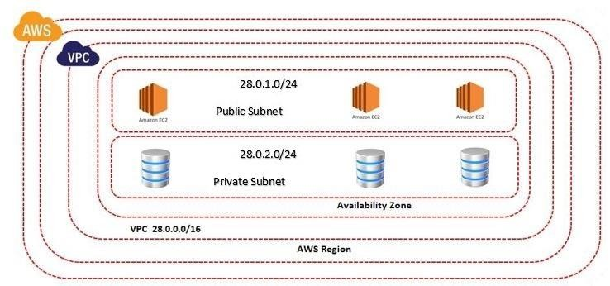

* AWS Reserve 5 IP Addresses (First 4 & Last 1) in each subnet
* These 5 IP Addresses are not available for use and can’t be assigned to an EC2 Instance.
  + For example, if your VPC has a CIDR of 192.168.0.0/16, one of your subnets may have a CIDR of 192.168.100.0/24.
  + This range covers 192.168.100.0– 192.168.100.255, which yields a total of 256 addresses.

1. First four addresses: 192.168.100.0 –192.168.100.3 & Last IP
   * 1. Address: 192.168.100.255
2. 192.168.100.0: Network address
3. 192.168.100.1: Reserved by AWS for the VPC router.
4. 192.168.100.2: Reserved by AWS for mapping to AWS-provided DNS.
5. 192.168.100.3: For Future Use
6. 192.168.100.255: Network broadcast address. We do not support broadcast in a VPC, therefore we reserve this address.

* **Private Subnet**
* **Public Subnet**

## **Private Subnet:** Instances in the private subnet are back-end servers that don't need to accept incoming traffic from the internet and therefore do not have public IP addresses. By default every subnet is the private subnet. For Example Database server

* **Public Subnet:** A public subnet is a subnet that's associated with a route table that has a route to an internet gateway. For Example Webserver
* Click on subnets
* We are able to see all the default subnets
* Click on create subnet
* Select the VPC in which we want to create the subnet
* Enter subnet name, Select availability zone & Enter IPV4 CIDR Block.
* Click on Create subnet
* Create One More Subnet

# Select the subnet

Actions

Edit Subnet Settings

* Check the Enable auto-assign public IPV4 address

# Click on save.